**Oct 2019**

**Publications with REL affiliation:**

Renewable Energy Laboratory (REL)

**Members:**

**Dr Dhafer Almakhles**

**Dr Umashankar Subramaniam**

**Dr Sagar Mahajan Bhaskar**

**Mission**

**REL** aims to conduct high quality research in the field of renewable and sustainable energy to meet the requirements of the society and Vision 2030. REL aims to provide academic support and scientific consultancy to the national and international industries. REL is committed to utilize University allocated resources to direct and unify the research efforts of PSU faculty members by applying their diverse expertise and bring it to the field of renewable energy. REL aims to increase the impact of PSU research, help the members in their professional development, and accomplish the PSU mission.

**Vision**

REL targets the construction and the building a robust scientific basis specifically directed towards enhancing the scientific society within PSU and KSA in the field of Renewable Energy and control engineering. The lab supplies students and researchers with the essential tools aimed towards orienting and improving their scientific mindset in Renewable Energy and control engineering.

**Achievement**

**Since REL** has been establishing Jan 2019:

* **25** papers submitted to ISI/Scopus journals.
* **12** papers were accepted
* **7** papers accepted with major revisions
* **6** papers under review. More details can be found in Table: 1.
* Presented **7** IEEE conference papers.
* Joint proposal to ministry education/energy

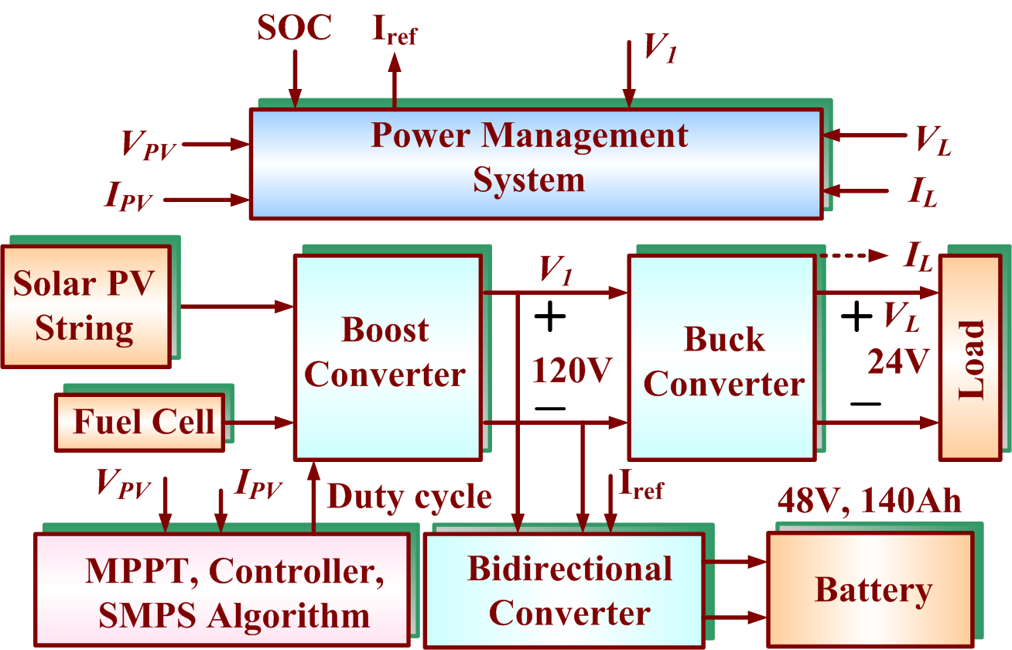

**Figure 1:** Block diagram of the proposed solar PV Systems in Renewable Energy Lab.

**Research plan**

**REL** research plan is divided to the following phases:

* **First Phase:** Recruitment of expert researchers in the field of Renewable Energy, and power electronics , energy efficiency and smart grid
* **Second Phase:** Establish training Center (PSU-RETC) for self-funding REL and consultancy on energy efficiency services for industries.
* **Third phase:** Research projects to get external fund from Industry related to RE or applying for joint research projects related to Energy inside or outside KSA.

**Published/submitted works**

**Publications**

|  |  |  |
| --- | --- | --- |
| **#** | **Reference** | **Indexing** |
| J.1 | **D. Almakhles,** [Sliding mode control as binary‐based quantizers](javascript:void(0)), Asian Journal of Control (2019) | ISI/Scopus |
| J.2 | **D. Almakhles,** A Swain, **U. Subramaniyan,”** Single-bit modulator for wireless power transfer system, International Journal of Power Electronics and Drive System, Vol. 10, No. 3, September 2019, pp. 1270∼1280 | Scopus |
| J.3 | **U. Subramaniam,** S. Ganesan, **Mahajan Sagar Bhaskar,** Sanjeevikumar Padmanaban , Frede Blaabjerg and **Dhafer J. Almakhles,** “Investigations of AC Microgrid Energy Management System using Distributed Energy Resources and Plug-in Electric Vehicle”, Energies – MDPI (2019) – In press. | ISI/Scopus |
| J.4 | **D. Almakhles,** R Sakthivel, A Swain, K Almustafa, **U. Subramaniyan,** “A generalized one-bit control system Using Delta-Sigma-Quantizer”, IEEE Access. | ISI/Scopus |
| J.5 | R. Sakthivel, S Mohanapriya, **DJ Almakhles,** [Robust Tracking and Disturbance Rejection Performance for Vehicle Dynamics](javascript:void(0)), IEEE Access 7, 118598-118607 | ISI/Scopus |
| J.6 | P. K. Maroti et al., "New tri-switching state non-isolated high gain DC–DC boost converter for microgrid application," in IET Power Electronics, vol. 12, no. 11, pp. 2741-2750, 18 9 2019.doi: 10.1049/iet-pel.2019.0236 | ISI/Scopus |
| J.7 | [V.K. Arun Shankar](https://www.mdpi.com/search?authors=V.K.%20Arun%20Shankar&orcid=) ,[**Umashankar Subramaniam**](https://www.mdpi.com/search?authors=Umashankar%20Subramaniam&orcid=)**,** [Sanjeevikumar Padmanaban](https://www.mdpi.com/search?authors=Sanjeevikumar%20Padmanaban&orcid=0000-0003-3212-2750), [Jens Bo Holm-Nielsen](https://www.mdpi.com/search?authors=Jens%20%20Bo%20Holm-Nielsen&orcid=), [Frede Blaabjerg](https://www.mdpi.com/search?authors=Frede%20Blaabjerg&orcid=0000-0001-8311-7412) and [S. Paramasivam](https://www.mdpi.com/search?authors=S.%20Paramasivam&orcid=), “Experimental Investigation of Power Signatures for Cavitation and Water Hammer in an Industrial Parallel Pumping System”, Energies 2019, 12(7), 1351; https://doi.org/10.3390 /en12071351 - 08 Apr 2019 | ISI/Scopus |
| J.8 | [**Umashankar Subramaniam**](https://www.mdpi.com/search?authors=Umashankar%20Subramaniam&orcid=0000-0003-3541-9218)**,** [**Sagar Mahajan Bhaskar**](https://www.mdpi.com/search?authors=Sagar%20%20Mahajan%20Bhaskar&orcid=0000-0002-3147-2532)**,** [**Dhafer J. Almakhles**](https://www.mdpi.com/search?authors=Dhafer%20J.Almakhles&orcid=), [Sanjeevikumar Padmanaban](https://www.mdpi.com/search?authors=Sanjeevikumar%20Padmanaban&orcid=0000-0003-3212-2750) and [Zbigniew Leonowicz](https://www.mdpi.com/search?authors=Zbigniew%20Leonowicz&orcid=), “[Investigations on EMI Mitigation Techniques: Intent to Reduce Grid-Tied PV Inverter Common Mode Current and Voltage](https://www.mdpi.com/1996-1073/12/17/3395)”,  Energies 2019, 12(17), 3395; https://doi.org/10.3390 /en12173395 - 03 Sep 2019 | ISI/Scopus |
| J.9 | [Veeramani Bagyaveereswaran](https://www.mdpi.com/search?authors=Veeramani%20Bagyaveereswaran&orcid=0000-0002-7622-9608), [**Subramaniam Umashankar**](https://www.mdpi.com/search?authors=Subramaniam%20Umashankar&orcid=0000-0003-3541-9218) and [Pachiyappan Arulmozhivarman](https://www.mdpi.com/search?authors=Pachiyappan%20Arulmozhivarman&orcid=) “Simulation Tool for Tuning and Performance Analysis of Robust, Tracking, Disturbance Rejection and Aggressiveness Controller”, *Algorithms,* 2019, 12(7), 144; <https://doi.org/10.3390/a12070144> | ISI/Scopus |
| J.10 | Bharatiraja Chokkalingam, **Mahajan Sagar Bhaskar,** Sanjeevikumar Padmanaban, Vigna K. Ramachandaramurthy, and Atif Iqbal, “Investigations of Multi-Carrier Pulse Width Modulation Schemes for Diode Free Neutral Point Clamped Multilevel Inverters*” Journal of Power Electronics*, Vol. 19, No. 3, pp. 702-713, May 2019 | ISI/Scopus |
| J.11 | A. R. Kumar, **M. S. Bhaskar, U. Subramaniam, D. Almakhles,** S. Padmanaban and J. Bo-Holm Nielsen, "An Improved Harmonics Mitigation Scheme for a Modular Multilevel Converter," in IEEE Access, vol. 7, pp. 147244-147255, 2019. doi: 10.1109/ACCESS.2019.2946617 | ISI/Scopus |
| J.12 | **D. Almakhles,** C Wanigasekara, A Swain, K Almustafa, **U. Subramaniyan,** “[Hybrid delta modulator: stability analysis using sliding mode theory](javascript:void(0))”, Systems Science & Control Engineering 7 (1), 234-242 (Wily) | Scopus |

**Publications accepted with minor/major revision**

|  |  |  |  |
| --- | --- | --- | --- |
| J.13 | Maximizing Energy-Efficiency for Bidirectional Relay Aerial Robotic Networks | Revision | ISI/Scopus |
| J.14 | A State-of-the-Art review on Conducted Electromagnetic Interference in Power Electronic Converters | Revision | ISI/Scopus |
| J.15 | EPAW: Efficient Privacy Preserving Anonymous Mutual Authentication Scheme For Wireless Body Area Networks (WBANs) | Revision | ISI/Scopus |
| J.16 | Sliding Mode Control and Backstepping for Quadrotor Trajectory Tracking Application | Revision | ISI/Scopus |
| J.17 | Non-fragile fault alarm-based hybrid control for the attitude quadrotor model with actuator saturation | Revision | ISI/Scopus |
| J.18 | Design of uncertainty and disturbance estimator-based tracking control for fuzzy switched systems | Revision | ISI/Scopus |
| J.19 | Design of robust tracking and disturbance attenuation control for stochastic control systems | Revision | ISI/Scopus |



|  |  |  |
| --- | --- | --- |
| J.20 | Fault estimations and non-fragile control design for fractional-order multi-weighted complex dynamical networks | Q1-ISI |
| J.21 | The Analysis of Adaptive Delta-Modulator in Sliding Mode Control | Q2-ISI |
| J.22 | Repetitive control design for vehicle lateral dynamics with state-delay | Q1-ISI |
| J.23 | Improved “K” type seven-level switched-capacitor inverter (K-7LSCI) topology with self-balancing | Q1-ISI |
| J.24 | A New Cross Connected Compact Switched-Capacitor Nine Level Inverter (C3SC-9L-I) Topology | Q1-ISI |
| J.25 | Using Sigma-Delta Quantizer Based PI for Inductive Power Transfer Systems | Scopus |

**Our International Collaborators**

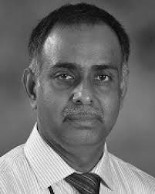

* He has been on the Editorial Board of international journals, including IEEE ACCESS, Journal of the Franklin Institute, Neurocomputing.
* We co-author several papers,
* We supervise two PhD students working on control systems for PV systems

**Publications Under Review**

**Name:** Dr. Saktheviel R.

[**Education**](https://www.google.com/search?safe=strict&q=frede+blaabjerg+education&stick=H4sIAAAAAAAAAOPgE-LVT9c3NEw2LElOSyvP0JLOTrbSL0jNL8hJBVJFxfl5VqkppcmJJZn5eYtYJdOKUlNSFZJyEhOTslKL0hXgcgCsIE7zSgAAAA&sa=X&ved=2ahUKEwimso6kkKrlAhUPxYUKHYrQCUIQ6BMoADAWegQIDhAN)**:**Bharathiar University, India

[**H-index**](https://www.google.com/search?safe=strict&q=frede+blaabjerg+h-index&stick=H4sIAAAAAAAAAOPgE-LVT9c3NEw2LElOSyvP0JLKTrbSL0jNL8hJ1S9OzsjPSSyyyojPzEtJrVjEKp5WlJqSqpCUk5iYlJValK6QoQuWAQAq5tW4RwAAAA&sa=X&ved=2ahUKEwimso6kkKrlAhUPxYUKHYrQCUIQ6BMoADAVegQIDhAK)**:**51

**Citations:** 7800

**Name:** Dr. Sanjeevikumar P.

[**h-index**](https://www.google.com/search?safe=strict&q=frede+blaabjerg+h-index&stick=H4sIAAAAAAAAAOPgE-LVT9c3NEw2LElOSyvP0JLKTrbSL0jNL8hJ1S9OzsjPSSyyyojPzEtJrVjEKp5WlJqSqpCUk5iYlJValK6QoQuWAQAq5tW4RwAAAA&sa=X&ved=2ahUKEwimso6kkKrlAhUPxYUKHYrQCUIQ6BMoADAVegQIDhAK)**:**24

**Citations:** 2450

[**Education**](https://www.google.com/search?safe=strict&q=frede+blaabjerg+education&stick=H4sIAAAAAAAAAOPgE-LVT9c3NEw2LElOSyvP0JLOTrbSL0jNL8hJBVJFxfl5VqkppcmJJZn5eYtYJdOKUlNSFZJyEhOTslKL0hXgcgCsIE7zSgAAAA&sa=X&ved=2ahUKEwimso6kkKrlAhUPxYUKHYrQCUIQ6BMoADAWegQIDhAN)**:**[University of Aalborg](https://www.google.com/search?safe=strict&q=Aalborg+University&stick=H4sIAAAAAAAAAOPgE-LVT9c3NEw2LElOSyvPUOLUz9U3MDIsSSvUks5OttIvSM0vyEkFUkXF-XlWqSmlyYklmfl5i1iFHBNzkvKL0hVC8zLLgLKZJZUAcjJX5E4AAAA&sa=X&ved=2ahUKEwimso6kkKrlAhUPxYUKHYrQCUIQmxMoATAWegQIDhAO)

[**Residence**](https://www.google.com/search?safe=strict&q=frede+blaabjerg+residence&stick=H4sIAAAAAAAAAOPgE-LVT9c3NEw2LElOSyvP0JLPKLfST87PyUlNLsnMz9MvSM0vyEm1KkotzkxJzUtOXcQqmVaUmpKqkJSTmJiUlVqUrgCXAwAsDybgTgAAAA&sa=X&ved=2ahUKEwimso6kkKrlAhUPxYUKHYrQCUIQ6BMoADAXegQIDhAR)**:**[Denmark](https://www.google.com/search?safe=strict&q=Denmark&stick=H4sIAAAAAAAAAOPgE-LVT9c3NEw2LElOSyvPUOIGcY0MC0yrDDO05DPKrfST83NyUpNLMvPz9AtS8wtyUq2KUoszU1LzklMXsbK7pOblJhZlAwCpd2ZySQAAAA&sa=X&ved=2ahUKEwimso6kkKrlAhUPxYUKHYrQCUIQmxMoATAXegQIDhAS)

* He serves as an Editor/Associate Editor/Editorial Board of refereed journals, in particular, the IEEE Systems Journal, IEEE ACCESS journals, IET Generation, Transmission and Distribution, and FACTS journals (Canada).
* He is the main supervisor REL Member, Dr. Mahajan Sagar Bhaskar

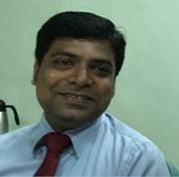

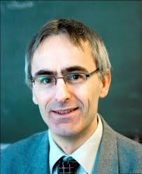

**Name:** Dr. Frede Blabjerg

[**h-index**](https://www.google.com/search?safe=strict&q=frede+blaabjerg+h-index&stick=H4sIAAAAAAAAAOPgE-LVT9c3NEw2LElOSyvP0JLKTrbSL0jNL8hJ1S9OzsjPSSyyyojPzEtJrVjEKp5WlJqSqpCUk5iYlJValK6QoQuWAQAq5tW4RwAAAA&sa=X&ved=2ahUKEwimso6kkKrlAhUPxYUKHYrQCUIQ6BMoADAVegQIDhAK)**:**142

**Citations:** 96089

[**Education**](https://www.google.com/search?safe=strict&q=frede+blaabjerg+education&stick=H4sIAAAAAAAAAOPgE-LVT9c3NEw2LElOSyvP0JLOTrbSL0jNL8hJBVJFxfl5VqkppcmJJZn5eYtYJdOKUlNSFZJyEhOTslKL0hXgcgCsIE7zSgAAAA&sa=X&ved=2ahUKEwimso6kkKrlAhUPxYUKHYrQCUIQ6BMoADAWegQIDhAN)**:**[University of Aalborg](https://www.google.com/search?safe=strict&q=Aalborg+University&stick=H4sIAAAAAAAAAOPgE-LVT9c3NEw2LElOSyvPUOLUz9U3MDIsSSvUks5OttIvSM0vyEkFUkXF-XlWqSmlyYklmfl5i1iFHBNzkvKL0hVC8zLLgLKZJZUAcjJX5E4AAAA&sa=X&ved=2ahUKEwimso6kkKrlAhUPxYUKHYrQCUIQmxMoATAWegQIDhAO)

[**Residence**](https://www.google.com/search?safe=strict&q=frede+blaabjerg+residence&stick=H4sIAAAAAAAAAOPgE-LVT9c3NEw2LElOSyvP0JLPKLfST87PyUlNLsnMz9MvSM0vyEm1KkotzkxJzUtOXcQqmVaUmpKqkJSTmJiUlVqUrgCXAwAsDybgTgAAAA&sa=X&ved=2ahUKEwimso6kkKrlAhUPxYUKHYrQCUIQ6BMoADAXegQIDhAR)**:**[Denmark](https://www.google.com/search?safe=strict&q=Denmark&stick=H4sIAAAAAAAAAOPgE-LVT9c3NEw2LElOSyvPUOIGcY0MC0yrDDO05DPKrfST83NyUpNLMvPz9AtS8wtyUq2KUoszU1LzklMXsbK7pOblJhZlAwCpd2ZySQAAAA&sa=X&ved=2ahUKEwimso6kkKrlAhUPxYUKHYrQCUIQmxMoATAXegQIDhAS)

[**Awards**](https://www.google.com/search?safe=strict&q=frede+blaabjerg+awards&stick=H4sIAAAAAAAAAOPgE-LVT9c3NEw2LElOSyvP0JLNTrbSTyxPLEqBkPHlmXl5qUVWYE7xIlaxtKLUlFSFpJzExKSs1KJ0BYgEAEDJaKdJAAAA&sa=X&ved=2ahUKEwimso6kkKrlAhUPxYUKHYrQCUIQ6BMoADAYegQIDhAV)**:**[Global Energy Prize for Unconventional Energy](https://www.google.com/search?safe=strict&q=Global+Energy+Prize+for+Unconventional+Energy&stick=H4sIAAAAAAAAAOPgE-LVT9c3NEw2LElOSyvPUIJwM8zycgqNS3K0ZLOTrfQTyxOLUiBkfHlmXl5qkRWYU7yIVdc9Jz8pMUfBFSiYXqkQUJRZlaqQll-kEJqXnJ9XlppXkpmfB5cHAE1uZFNvAAAA&sa=X&ved=2ahUKEwimso6kkKrlAhUPxYUKHYrQCUIQmxMoATAYegQIDhAW)

**Note:**

* He is the president of IEEE power electronics society
* He is the supervisor REL Member,

Dr. Mahajan Sagar Bhaskar